Blackwater Triathlon Club

presents

BLACKWATER LEISURE CHARITY TRIATHLON 2025

Sunday 07 September 2025

Novice race: Swim 200m; Cycle 12km; Run 3km
Sprint Race: Swim 400m; Cycle 23km; Run 6km
TriStar/Youth Aquathlon: Swim 400m; Run 3km

Registration: Saturday 06 September - 15:30 – 17:30hrs
Sunday 07 September - 06:00 – 07:00hrs

Race Briefing: Sunday 07 September - 06:45hrs (Café/Poolside)
First Start: Sunday 07 September - 07:00hrs Approx.

Dear Triathlete,
We welcome you to the fifteenth running of the Blackwater Leisure Charity Triathlon. This year you will be helping to raise funds for Farleigh Hospice, who provide care for those effected by life limiting illness and bereavement.
This year’s event is kindly supported again by Blackwater Leisure Centre (who provides the use of the swimming pool, parking and the changing facilities), Maldon District Council for the use of the Promenade Park. Essex Community First Aid Events Volunteers, and the members of the Blackwater Triathlon Club their families & friends for giving up their time to set up and run the event.
Sunday will see approximately 100 competitors swimming at the leisure center, before taking to their bikes on the roads of Maldon and finally running in Promenade Park before returning to the leisure center to collect a finisher’s medal. Our race is sanctioned by British Triathlon and authorized by Essex Police Road Safety Department.
LOCATION/PARKING
The event takes place at The Blackwater Leisure Centre, Park Drive, Maldon, Essex CM9 5UR.
Zone 1 parking is located at the Leisure Centre, approximately 75 spaces which will be filled first.
Zone 2 parking is at Maddison Heights, next door to the Leisure Centre with an additional 35 spaces.
The Promenade Park also provides plenty of parking capacity.
Zone 1: what3words /// The simplest way to talk about location ///compiled.appointed.manicured
Zone 2: what3words /// The simplest way to talk about location ///plugged.newer.thrusters
Once Zone 1 is full our Marshalls will direct you to the overflow spaces located either next door at Madison Heights or towards the Promenade Park which can only be accessed from 0700hrs.

NB: The Leisure Centre remains open to the public during this time.
REGISTRATION

All competitors have the choice of registering either Saturday afternoon (06 Sept) between 15:30 – 17:30hrs or Sunday morning (07 Sept) between 05:45 hours and 07:00hrs.
Those who have entered the Novice event please ensure you register in good time as you will be starting earlier. I would encourage as many of you to register on the Saturday afternoon as possible; it takes the pressure off you and the organizers. It also gives you an opportunity to ask questions and understand the event.
Registration will take place in the large tent erected next to the transition. You will be issued with your race number at registration. Timing chips will only be available on Sunday morning as you go through to the pool for the start of your race – NO timing chip means NO time will be registered.
Please bring with you safety pins or a number belt; you will also be issued with a corresponding numbered sticker for your bike & cycle helmet.

BTF race license / day license
Each competitor will be required to have a BTF day license. The BTF day license is a license for racing and covers your public liability insurance for the day. It is electronically attached to the race information.

Or be a member of the BTF (£3 refunded at registration on presentation of a valid BTF race license).

Transition will open for bike racking on Sunday from 05:45 and will close approximately 07:15 so please ensure that your bike is racked in transition. You cannot enter transition area until you have registered. Once registered please proceed to transition, rack your bike and prepare your equipment for the race.

Your bike should be roadworthy. If there is any concern this will be directed to British Triathlon Technical Officials.
Please note race numbers must be clearly displayed on your back for the bike section and on your front for the run section. Number belts are permitted.

Sunday morning Summary

- Register
- Stick your race numbers to your bike and helmet before heading for transition
- Have your helmet on when entering transition where it and your bike will be checked

TRANSITION

Only registered competitors may enter the transition area after showing valid race numbers. Please rack your bike at your corresponding number showing consideration when putting your bike on the rack and in setting out your cycling/running gear as space will be limited.

The transition area will be busy throughout the race so competitors who have completed their race will only be able to collect their bike and belongings when the transition marshals deem it safe to do so.

We will be quite tight for space in the transition area so we would ask that only essential items be by your bike in the transition area (these may include - towel, trainers, bike shoes, glasses, drinks and nutrition).

SAFETY There will be a race briefing in the Leisure Centre adjacent to poolside approximately 06:45hrs.

The organizers have worked hard to make the event as safe as possible however your actions will contribute significantly to ensuring the event passes off without incident.

Some guidelines:
- Although you may be racing you must ensure the safety of yourself and others.
- Be aware of the many small dangers that an event such as this can present and ensure you follow the instructions contained within this document and those given by the marshals and race director. Failure to do so may result in disqualification.
- The cycle route is on public roads, and you must follow the Highway Code at all times.
- Ensure all your equipment is fit for purpose. Your bike must be roadworthy with the brakes working. Helmet must be intact.
- Clothing must be suitable for this sort of event. Do not wear anything that could become entangled with your bike.
- MP3 or music players of any type are not permitted, Failure to abide with this instruction will result in disqualification.

SWIM

The swim takes place in the pool at the Blackwater Leisure Centre, which is 25m in length and has 4 lanes. Competitors will start in race number order, with the novices first. The swim will start and finish at the shallow end.

Please wait in the café area prior to their start. It is your responsibility to be in the café ready to be called through, so please take note of how the numbers are progressing. Collect your timing chip as you make your way to the pool.
NB: Front fastening tri-suits and tops must be fully zipped up at all times unless a top is worn underneath. No part of the torso may be uncovered except for the swim and a suitable top must be worn before setting out on the bike segment.

Overtaking

Overtaking is permitted but you are asked to do this with caution as the lanes will be busy. Only overtake if you are sure that you can do this without hindering either the person you are overtaking or any on coming competitors.

If someone is behind you wishing to overtake then please pull over briefly at the end of the lane to allow them to pass safely, you will benefit more from following a faster swimmer than holding them up.

Novice only: 8 lengths / 200 metres

To simplify the novice swim for both the competitors and organizers we are adopting the “Duck the lane rope” approach this year. The Novice competitor will start and swim clockwise up and back in lane 1. They will then duck the lane rope and repeat in lane 2, 3 and 4 exiting through into transition.

1  START | 2 | 3 | 4
FINISH

Sprint: 16 lengths / 400 metres

Sprint competitors will stay in their allocated lane for the full 16 lengths.

The race starter will call you to your lane. The maximum number of swimmers in a lane will be two. With one person per lane waiting at poolside ready to enter the water. Please maintain discipline regarding your position in the swim lane to avoid collision.

Proceed with caution as you leave the pool area as there is a strong chance of slipping due to the water on the floor.
You are responsible for counting the number of lengths, sprint distance athletes are required to swim 16 lengths of the pool. No more, No less. Whilst we have marshals on poolside offering you support; the responsibility is on you. Remember: 16 lengths = 400m.

Please note:
- No diving.
- Front crawl or breaststroke is permitted. No backstroke or butterfly
- No running on poolside.

BIKE: NO Cycle helmet = NO RACE!

Novice: 1 lap of course [12km]
Sprint: 2 laps of course [23km] – please note it is your responsibility to count the laps!

Before arriving on the day please ensure:

- Your bike is in a roadworthy and safe condition.
- Helmets must be in good condition and carry a recognized safety mark [i.e., ANSI British Standard or Snell Sticker].

As you enter the transition area from the swim, please remember it is a very busy area, with competitors at different stages of the race. Please take care! When you arrive at your cycle you must securely fasten your helmet before un-racking your bike, failure to do so will result in a stop/go penalty where possible, alternatively 15 seconds will be added to your time. You must then push your bike out of transition, following the BIKE EXIT sign to the designated BIKE MOUNT AREA.

Bike Safety

The bike course is on public highways which are fully open to other road users. You must follow the Highway Code at all times and be prepared to give way at all junctions as appropriate. Marshals are not permitted to carry out traffic control duties but are there to warn competitors and other road users of the added risks associated with the cycle event.

Essex Police have made it known that should competitors be seen to be riding dangerously or breaking the rules of the Highway Code, they will be stopped, and due consideration will be given to prosecution.
Do not jeopardize either your safety or the future of this event by riding recklessly. Please also be courteous to other road users and Marshalls.

Drafting is not permitted.

This race is a non-drafting race for all categories (the draft zone is 12 meters).
A competitor may enter the draft zone of another competitor but must be seen to be progressing through it.
A maximum of 25 seconds is allowed to progress though the draft zone of another competitor.
If an overtaking maneuver is not completed within 25 seconds, the overtaking cyclist must drop back.
You are also reminded no 'side by side' riding will be allowed.
The race Technical Official will be looking for infringements and will issue time penalties and may disqualify you. Under new guidelines it is not required for the Technical Official to inform you until the event is completed.

Competition & Technical rules are available via the British Triathlon website www.britishtriathlon.org

Bike course

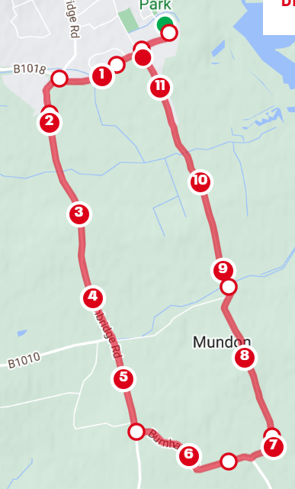

Point 1: https://what3words.com/coarser.fires.prouder . Once on your bike it is a short ride [approx. 100m] to the car park exit. Turn LEFT onto Park Drive and proceed toward the first roundabout junction with Mundon Road.

Point 2: https://what3words.com/blunders.inflict.mascots . 2nd exit (straight over), proceed along Limbrook Way to the next roundabout.

Point 3: https://what3words.com/pods.forecast.sandbags . Turn LEFT into Fambridge Road (first exit). This road is undulating, and you will remain on this road for approximately 2.5 miles.

Point 4: https://what3words.com/giggle.symphonic.cracks . Turn LEFT on the Burnham Road and head towards the village of Mundon.

Point 5: https://what3words.com/nurse.punctuate.firms . Turn LEFT into Mundon Road

Caution: this junction can be approached fast & tightens on the exit causing riders to run wide onto the wrong side of the road. Please slow to a controllable speed for your ability through this junction. If competitors are seen to cross onto the wrong side of the road, they will be disqualified. This is for your safety!

Note: Furthest point on the course before returning to the Leisure Centre. On the Mundon Road you pass through the village heading back towards Maldon.

Point 6: https://what3words.com/variation.eradicate.brownish At this point the Novice riders turn RIGHT at the roundabout back toward the Leisure Centre; whilst the Sprint riders turn LEFT to complete their second loop of the course, before executing the RIGHT turn at the roundabout back toward the leisure Centre.

Caution: The right turn at the Mundon Road/Park Drive roundabout is the most dangerous part of the cycle course so please take extreme care at this point and ensure that you give way to all traffic on the roundabout, including other competitors who may be crossing the roundabout from your right on their way out. Please slow down as you approach as you need to be prepared to stop to give way to traffic on the roundabout.

Proceed back along Park Drive and turn RIGHT into the Leisure Centre entrance.
Caution: Take care when making the right turn, be aware of other vehicles in the area especially on coming traffic (Marshals do not have the authority to stop traffic in your favour so please exercise caution).

Also note there is a slightly raised kerb at the entrance, please do not approach at an oblique angle as this may result in you coming off your bike. Continue riding your bike to the DISMOUNT LINE. Your time will be taken here for your bike split. You must then push your bike into transition, following the BIKE IN sign, and replace your bike on the racking. Only once your bike is racked may you remove your helmet.

Road conditions: will be assessed during the week and again on race morning and advised at the safety briefing.

Abuse of other road users, race staff, officials or the public by any competitor will result in an immediate disqualification from the event and a ban from all future events hosted by both the venue and the organizers. Please try to remain courteous on the road even if some other road users may not offer you the same respect.
Finally, if whilst out on the bike course you are unable to continue for whatever reason, please stay with your bike and we will have a vehicle making periodic circuits of the course that can pick you up.

RUN

Novice: 1 lap of course [3km]
Sprint: 2 laps of course [6km]

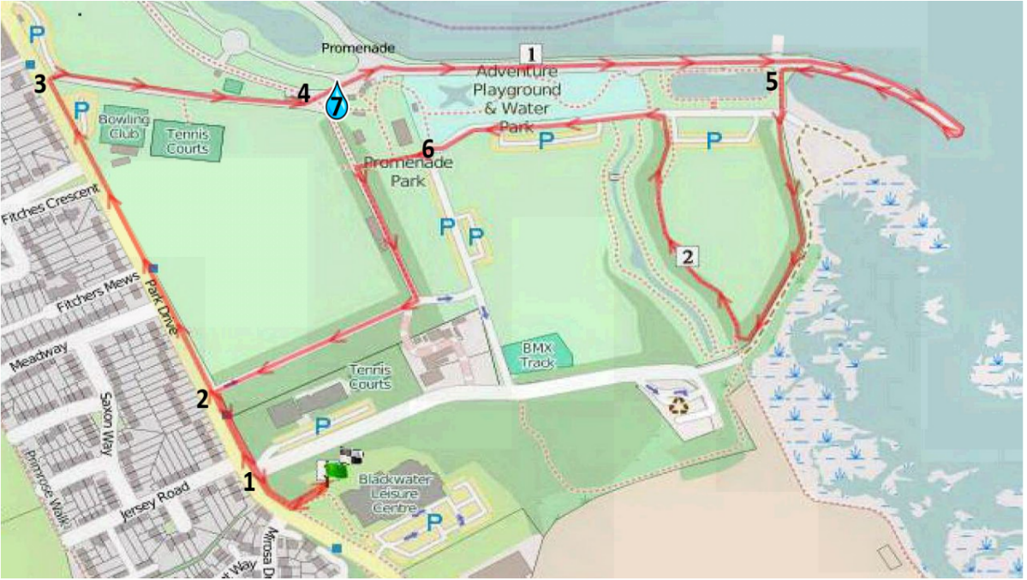
Once your cycle helmet is removed follow the RUN EXIT sign onto the run course.

Exit the Leisure Centre via the footpath, turn RIGHT and follow along Park Drive. Continue approx. 300 meters to the next right turn into the park through a gateway (it will be marshaled, and sign posted). Follow the footpath to the monument [the “Paperclips”] and down the hill to the river, continue along the Promenade (keeping to the left side of the path) until you reach the end of the Extension, where there is a 180-degree turning point at the Byrhtnoth (correct spelling!) Statue – and proceed back again keeping to the left-hand side.
On the return leg, immediately before the model boating lake turn LEFT along the footpath, cross the car park road and run onto the grass where you follow the tree-lined footpath in an inverted V-shape around Memorial Avenue. As you re-join the car park road turn LEFT running behind the play area and splash park. Beware of the shallow speed humps. At the top of a short slope turn LEFT along the footpath behind the cricket pavilion to a T-junction where you turn RIGHT. Follow the path under the trees.

The gates at the end of this drive mark the end of one lap. Competitors in the Novice event turn LEFT to return to the Leisure Centre. Competitors in the Sprint event turn RIGHT on the footpath along Park Drive away from the Leisure Centre to complete a second lap; On completion of the second lap turn LEFT at these gates on the footpath and return to the Leisure Centre.

The Park through which you are running is a popular destination for families and dog walkers and every effort will be made to keep you separate from them – but we would ask you to remain vigilant, be courteous and respectful.

TRISTAR3/YOUTH AQUATHLON:
Competitors who have entered the TriStar3 / Youth Aquathlon will start after the final swimmers in the Sprint Distance event, the distance is 400m followed by one loop of the run course set out for the triathlon. Competitors from the Novice/Sprint event will already be on the course as will volunteers to support you.
WATER STATIONS

Two water stations will be available on the run course: one in the Promenade Park (point 7), and one at the finish line!

MARSHALS

Special thank you to all those who set the event up on the Saturday and turn up early on a Sunday morning to marshal, without their help there would be no race. Please remember these people give up their time for nothing. BTF regulations stipulate the marshals are treated with courtesy and respect, foul or abusive language is not permitted. We appreciate you have paid your race entry fee and want to do your best, but any occurrence of abuse will result in disqualification at the discretion of the race director & BTF Technical Official.

CHECKLIST

Swim: Goggles, Swimming costume/trunks/Tri suit/own hat if needed
Bike: Bike, helmet, cycling shoes, shorts/shirt, puncture repair kit/spare tubes, pump, water bottle
Run: Running shoes, shorts/vest.
Misc.: Towel, socks, safety pins/number belt, sunglasses, sun protection.

RESULTS

Initial results will be published as competitors complete the race via a notice board at the timekeeping marquee.

Full split times will be published later on c/o East Essex Triathlon Club with a QR link shared by all on the day.
PRESENTATIONS

A presentation ceremony will take place at approx. 12:30 hours (or earlier if the race has finished).

THANK YOU

Thanks go to all those people that have so generously given of their time and resource in the planning and provision of this event; without them there would be no event and no charitable donation.

Blackwater Leisure Centre staff and management, Essex Police road safety department,
Maldon District Council,
Madison Heights
Essex Community First Aid Events Volunteers,

Have a great race!

Andrew Jopson

Blackwater Triathlon Club

